**Prerequisites:**

1. Java 11
2. Linux OS (Ubuntu)
3. 4 GB RAM Minimum

Link Referred: <https://www.digitalocean.com/community/tutorials/how-to-install-apache-kafka-on-ubuntu-20-04>

**Installation:**

1. Create a kafka user

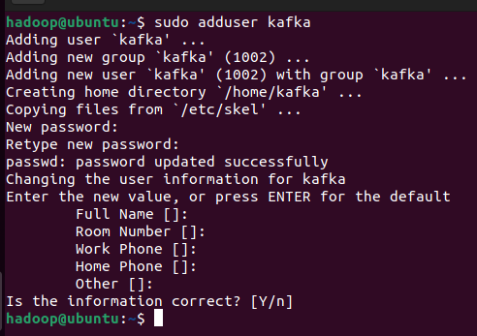

1. Add the Kafka user to the sudo list

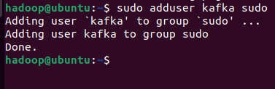

1. Log into kafka user

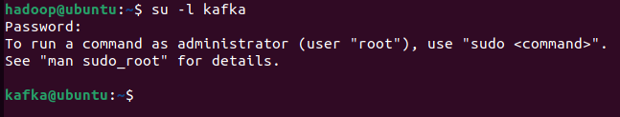

1. Download kafka

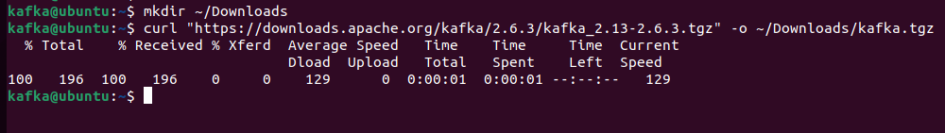

1. Create a directory where we will extract the contents of our Kafka binary file

**Error Faced**:



The download link given in the reference does not work, that version of Kafka is moved to the archive. Use this link: <https://archive.apache.org/dist/kafka/2.6.3/kafka_2.13-2.6.3.tgz>

1. Extract the downloaded file into the created kafka folder

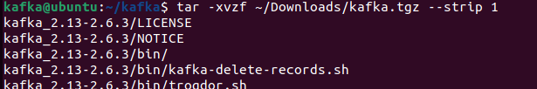

**Configuring Kafka**

1. Open kafka server.properties file



1. Add delete.topic.enable = true to the end of the file

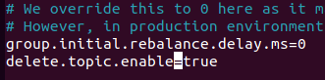

1. Change the directory where the Kafka logs are stored by modifying the logs.dir property at line 60 (To view line number either open with gedit or use nano -c ~/kafka/config/server.properties)

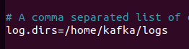

**Creating Systemd unit files and adding Zookeper to maintain Kafka files**

1. Open zookeeper.service file

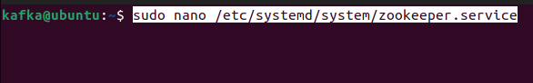

1. Add the following code

[Unit]

Requires=network.target remote-fs.target

After=network.target remote-fs.target

[Service]

Type=simple

User=kafka

ExecStart=/home/kafka/kafka/bin/zookeeper-server-start.sh /home/kafka/kafka/config/zookeeper.properties

ExecStop=/home/kafka/kafka/bin/zookeeper-server-stop.sh

Restart=on-abnormal

[Install]

WantedBy=multi-user.target

1. Create the systemd service file for kafka and add the following code

[Unit]

Requires=zookeeper.service

After=zookeeper.service

[Service]

Type=simple

User=kafka

ExecStart=/bin/sh -c '/home/kafka/kafka/bin/kafka-server-start.sh /home/kafka/kafka/config/server.properties > /home/kafka/kafka/kafka.log 2>&1'

ExecStop=/home/kafka/kafka/bin/kafka-server-stop.sh

Restart=on-abnormal

[Install]

WantedBy=multi-user.target

1. Start Kafka

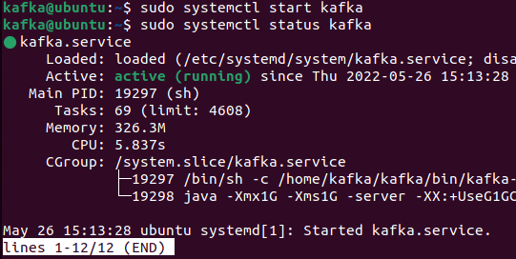

1. You now have a Kafka server listening on port 9092.
2. You have started the kafka service. But if you rebooted your server, Kafka would not restart automatically. To enable the kafka service on server boot, run the following commands

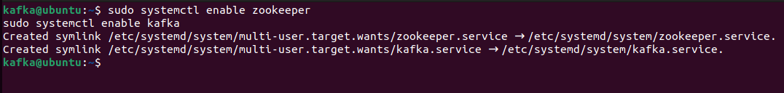

**Testing Kafka Installation**

We will test our Kafka installation. Specifically, we will publish and consume a “Hello World” message to make sure the Kafka server is behaving correctly.

Publishing messages in Kafka requires:

* A producer, who enables the publication of records and data to topics.
* A consumer, who reads messages and data from topics.

1. Create a Kafka topic



1. Publish the string "Hello, World" to the TestTopic topic



1. Now consume the message from TestTopic topic



1. The script will continue to run, waiting for more messages to publish. To test this, open a new terminal window and log into your server.

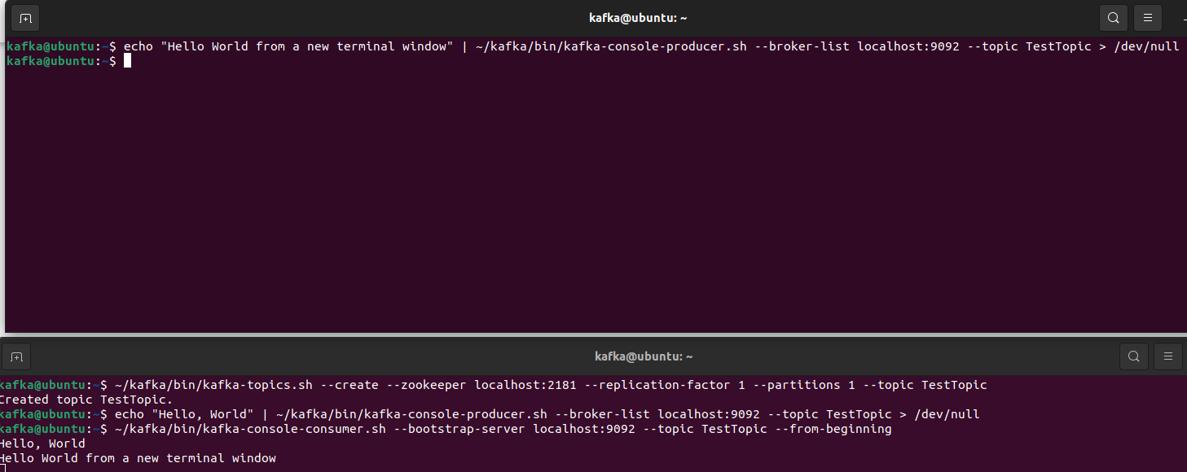

1. Install KafkaT which makes it easier to view details about your Kafka cluster and perform certain administrative tasks from the command line
2. Install Ruby

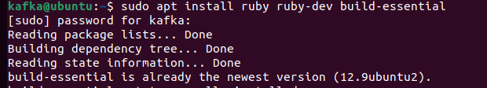

1. Install KafkaT

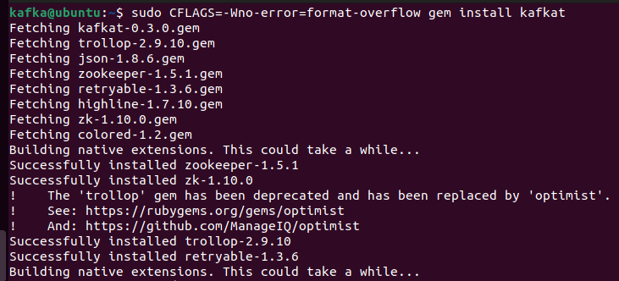

1. Create a new file called .kafkatcfg
2. Add the following lines to specify the required information about your Kafka server and Zookeeper instance

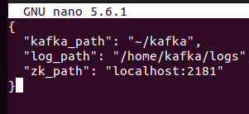

1. Test KafkaT

